March Madness Reading Challenge

This year, we encourage our families to take part in our March Madness Reading Challenge. The basic idea is to use the **bracket system** (like the NCAA basketball teams use) but replace the teams with **books**. The purpose is to create a discussion around the best books and decide what is the ultimate book of the year. The books that were chosen generally have to do with our current history cycle. At the end of the year, if the student has read the book that was deemed the ultimate book of the year, he or she may be awarded a grade prize. Here’s how it works:

* Students have a book list that corresponds to their grade grouping
* Begin reading the books and answer the 5 ws in your reading journal (this is necessary to count as your entry to win a grand prize.
* Beginning in March, each books gets a spot, paired against another in the first “round”
* Students vote for the better book of the pairing
* The winning book advances to the next round and brackets are updated after each vote
* March Madness rounds based upon grade grouping readings
* The final two books face off in the “Championship”

*Sample below

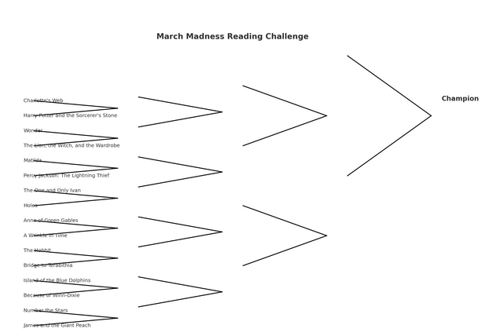

Lower Elementary Reading Challenge

Picture Books (all are available as read alouds on YouTube except for the last one)

* Seeker of Knowledge (Rumford)
* The Egyptian Cinderella (Climo)
* Exodus (Wildsmith)
* Mufaro’s Beautiful Daughters (Steptoe)
* Anansi the Spider (McDermott)
* Jesus and the Lion’s Den (Mitchell)
* The Priest with Dirty Clothes (Sproul)
* The Librarian Who Measured the Earth (Lasky)
* Tale of Three Trees (Hunt)
* The Garden, the Curtain, and the Cross (Laferton)
* Escape from Pompeii (Balit)
* Jesus and the Very Big Surprise (Goodgame)
* The Elephant’s Friend & Other Tales from India (Williams)
* What’s Your Angle, Pythagoras (Ellis)
* The Donkey Who Carried a King (Sproul)
* Kingdom Files: Who was Esther (Koceich) ($3.99USD ebook from christianbook.com)

Chapter Books

* The Trojan Horse (Little) Grade 3+ reading level ($7.99 Paperback from Amazon or Indigo.ca, $3.99 Kobo eBook from Indigo.ca)
* Life in the Great Ice Age (Oard) ($5.99USD eBook on masterbooks.com)
* Tirzah (Travis) (read aloud available on YouTube, or $9.99 Paperback and $5.99 Kobo eBook from Indigo.ca)
* A cry from Egypt (Auer) (read aloud available on YouTube, Paperback $16.50 from Indigo or $16.37 from Amazon)
* Star of Light (St. John) (read aloud on YouTube by Great Literature with Grandma Carla, $6.39USD eBook on [christianbook.com](http://christianbook.com) or $9.55 from Amazon)
* The Bark of the Bog Owl (Rogers) (read aloud on YouTube by Laura Malone, $19.50 from Indigo or $23.23 on Amazon)
* Adara (Gormley) ($21.99 Paperback from Indigo or Amazon, or $20.49 Kobo eBook from Indigo)
* Joel a Boy of Galilee (Johnston) (audiobook on Youtube and $7.99 eBook on Indigo)
* Twice Freed (St. John) (audiobook on Youtube or $13.95 Paperback from Indigo or Amazon)

Upper Elementary Reading Challenge

* Kingdom’s Dawn (Black)
* Shadow Hawk (Norton)
* Mara Daughter of the Nile (McGraw)
* The Tale of Troy (Green)
* The Wanderings of Odysseus (Sutcliffe)
* Jotham’s Journey (Ytreeide) (available on Youtube) FOR ADVENT
* Vinegar Boy (Hawse) A little pricey
* Black Ships Before Troy (Sutcliffe) Love the picture book version

Read Aloud:

* The Cat of Bubastes: A Tale of Ancient Egypt (Henty) available on Youtube
* D’Aulaires’ Book of Greek Myths (D’Aulaire)
* The Bronze Bow (Speare)
* Amon’s Adventure (Ytreeide) (A family story for easter) *Intense, not for sensitive children

Junior High Reading Challenge

* Out of the Silent Planet (Lewis)
* Shadow Hawk (Norton)
* Sons of the Prince (Rivers)
* Til we have faces: A myth Retold (Lewis)
* Counted with the Stars (Cossette) *sensitive topics
* The Tale of Troy (Green)
* The Wanderings of Odysseus (Sutcliffe)
* Mara, daughter of the Nile (McGraw)

High School Reading Challenge

* Out of the Silent Planet (Lewis)
* Til we have faces: A myth Retold (Lewis)
* The Odyssey (Homer)
* Counted with the Stars (Cossette)
* The Trial and Death of Socrates: (Plato/Jowett)
* Alexander the Great (Freeman)
* Julius Caesar (Shakespeare)
* The Flames of Rome (Maier)
* The Holiness of God (Sproul)
* The Pursuit of God (Towzer)
* Don’t Waste your Life (Piper)

**Reading Challenge - Additional Resources**

* Caesar’s Gallic Wars (Coolridge)
* Sons of the Prince (Rivers)
* The Robe (Douglas)
* Just Do Something: A liberating approach to finding God’s Will (DeYoung)
* Passion and Purity (Elliot)

Additional Suggestions for the History Cycle

Days of Elijah

Hittite Warrior

Ben Hur- A Tale of the Christ

Passages- Book 3- Anniston's Risk

ANCIENT TIMES

Constellations and their Myths: The Stories Behind Our Stars  
The Dragon Diaries  
Tales from the Old Testament  
Bible Stories: Great Men and Women from Noah through Solomon  
Story of the World, Volume I  
Tales from Cultures Far and Near  
Jewish Holiday Stories  
Pharaohs and Queens of Ancient Egypt  
Egyptian Treasures: Mummies & Myths  
Greek Myths  
Courage and A Clear Mind: True Adventures of Ancient Greeks  
She and He: Adventures in Mythology  
Heroes in Mythology  
Shakespeare for Children  
A Treasury of Wisdom: Stories of Hope and Inspiration  
Julius Caesar and the Story of Rome

G.A. Henty Titles-Ancient Times

The Young Carthaginian  
Beric The Briton  
For the Temple